**FAST**

**National University of Computer and Emerging Sciences**



**Web Programming**

**Lab#1**

**Submitted by:**

**Rimsha Sarfraz(21F-9244)**

**BSCS_6E**

**Submitted to: Mam Sumera Mustafa**

**Dated: 2nd Feb ,2023**

Task 1:

Code:

<!DOCTYPE html>

<html lang="en">

<head>

    <meta charset="UTF-8">

    <meta name="viewport" content="width=device-width, initial-scale=1.0">

    <title>MY First WEBPAGE</title>

</head>

<body>

    <header>

        <h1>Rimsha sarfraz</h1>

    </header>

    <section>

        <h2>Roll Number: 21F-9244</h2>

        <p>

            Hello! My name is Rimsha sarfraz, and I am a student of Fast University. This is my first webpage.

            This web page is only for entertainment.

        </p>

    </section>

</body>

</html>

Output:

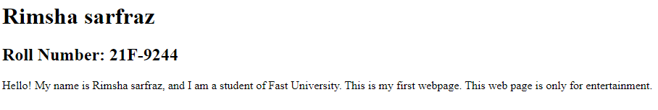

Task 2:

Code:

<!DOCTYPE html>

<html lang="en">

<head>

    <meta charset="UTF-8">

    <meta name="viewport" content="width=device-width, initial-scale=1.0">

    <title>Task 2</title>

</head>

<body>

    <b>This text is Bold</b>

<br>

    <strong>This text is Strong</strong>

    <br>

    <bi>This text is Big</bi>

    <br>

    <i>This text is ittalic</i>

    <br>

    <output>This text is COMPUTER OUTPUT</output>

    <br>

    <em>This text is emphasized</em>

    <br>

    <bi>This text <sub>subscript</sub> and <sup>superstrict</sup></bi>

    <br>

</body>

</html>

Output:

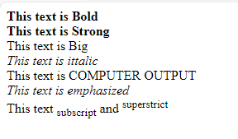

Task 3:

Code:

<!DOCTYPE html>

<html lang="en">

<head>

    <meta charset="UTF-8">

    <meta name="viewport" content="width=device-width, initial-scale=1.0">

    <title>MY First WEBPAGE</title>

</head>

<body>

    <header>

        <h1>Rimsha sarfraz</h1>

    </header>

    <section>

        <h2>Roll Number: 21F-9244</h2>

        <p>

            Hello! My name is Rimsha sarfraz, and I am a student of Fast University. This is my first webpage.

            This web page is only for entertainment.

        </p>

        <img src="C:\Users\F219244\Desktop\fast_logo\fasttt.png" alt="Fast University LOGO" width="500",height="500">

    </section>

</body>

</html>

Output:

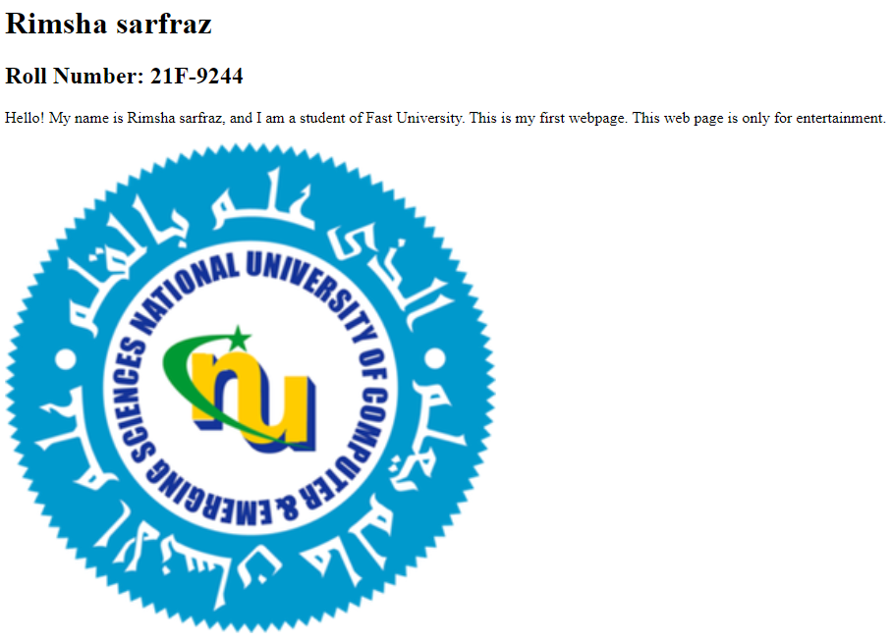

Task 4:

Code:

<!DOCTYPE html>

<html lang="en">

<head>

    <meta charset="UTF-8">

    <meta name="viewport" content="width=device-width, initial-scale=1.0">

    <title>MY First WEBPAGE</title>

</head>

<body>

    <header>

        <h1>Rimsha sarfraz</h1>

    </header>

    <section>

        <h2>Roll Number: 21F-9244</h2>

        <p>

            Hello! My name is Rimsha sarfraz, and I am a student of Fast University. This is my first webpage.

            This web page is only for entertainment.

        </p>

        <a href="https://www.fast.edu.pk" target="_blank">

        <img src="C:\Users\F219244\Desktop\fast_logo\fasttt.png" alt="Fast University LOGO" width="500",height="500">

        </a>

        <h3><b>We Have some Course languages</b> </h3>

        <ul type="circle">

            <li> Java</li>

            <li> C++.</li>

            <li> Python.</li>

            <li> HTML.</li>

            </ul>

            <h4><b>Steps to learn Java</b> </h4>

            <ol type="Number">

            <li> Brought a course </li>

            <li> Follow instructions.</li>

            <li> Take lectures from indian Youtubers </li>

            </ol>

    </section>

</body>

</html>

Output:

